AI ASSISTED CODING LAB
ASSIGNMENT 3.2
ENROLLMENT NO :2503A51L08
BATCH NO: 19
NAME: BHUKYA RAJESH
TASK1
TASK1 DESCRIPTION:- Ask AI to write a function to calculate compound interest, starting with only the function name. Then add a docstring, then input-output example

PROMPT:- "Write a Python function to calculate compound interest. Start by providing only the function name. Next, add a docstring that explains what the function does, its parameters, and its return value. Then, include an input-output example that demonstrates how to use the function and what result it produces." implement with example

CODE:-
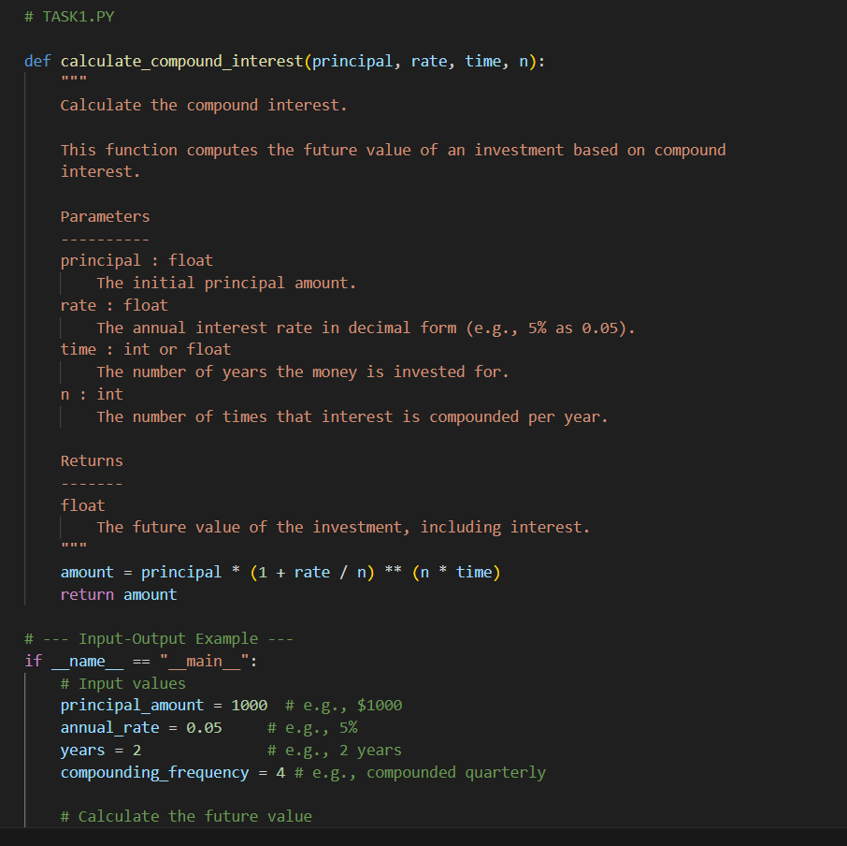
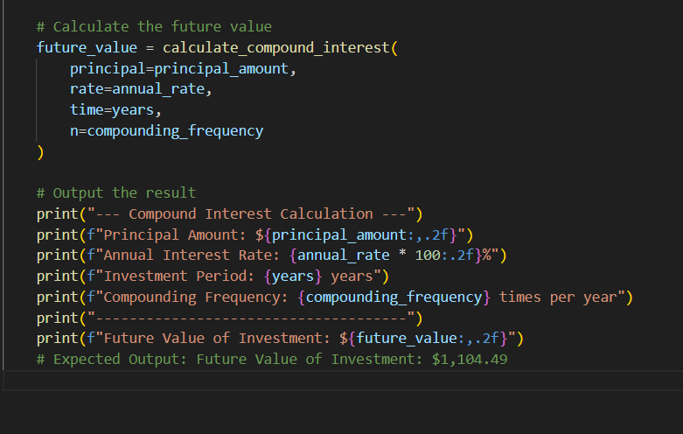
OUTPUT:-
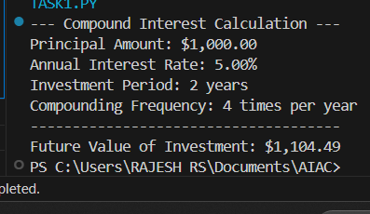

TASK2
TASK2 DESCRIPTION:- Do math stuff, then refine it to: # Write a function to calculate average, median, and mode of a list of numbers

PROMPT:- generate a python function to calculate average, median, and mode of a list of numbers that should be enter at runtime
CODE GENERATED :

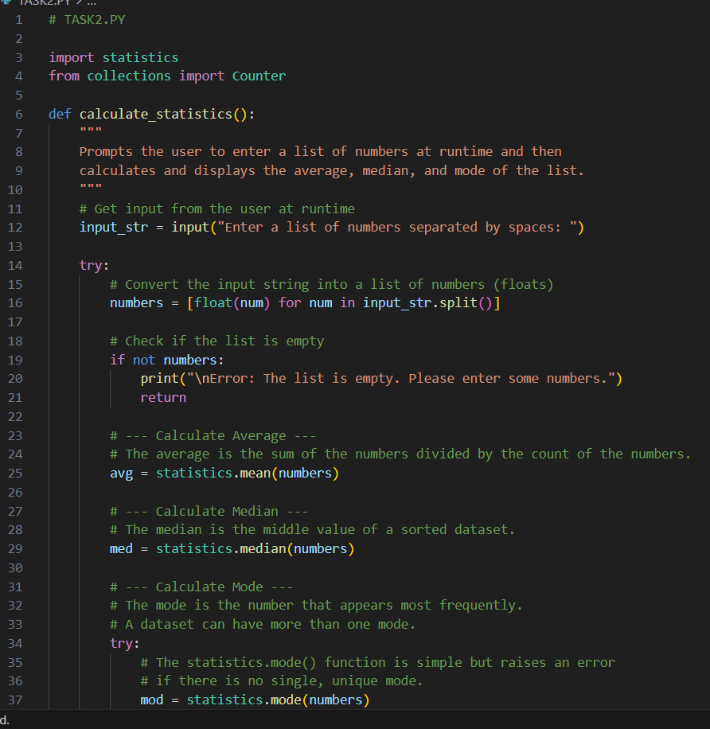
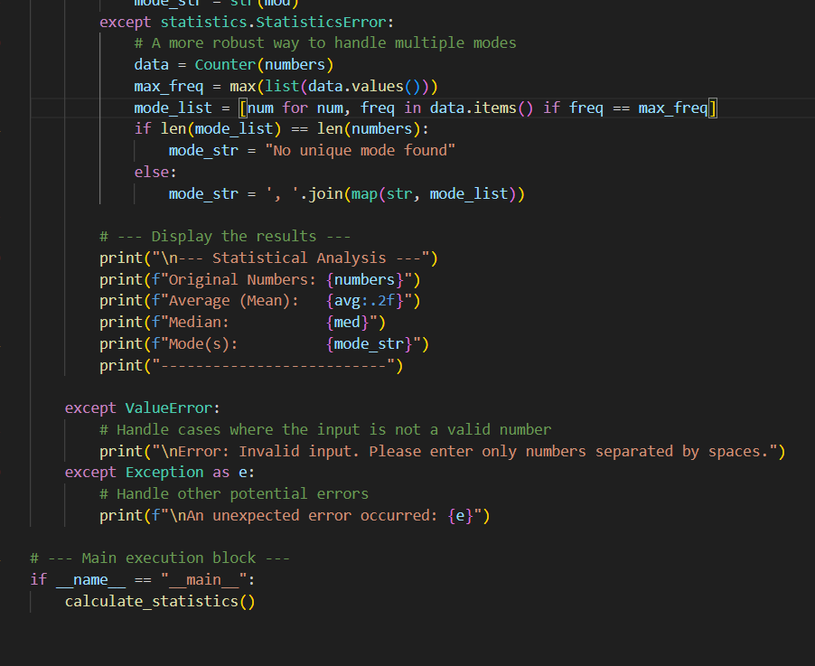

OUTPUT:-
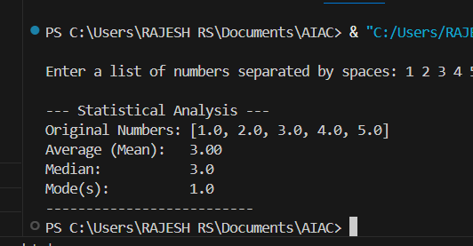

TASK3
TASK3 DESCRIPTION:- Provide multiple examples of input-output to the AI for convert_to_binary(num) function. Observe how AI uses few-shot prompting to generalize.

PROMPT:- generate a python program that provides multiple input–output examples for a Python function convert_to_binary(num) that converts a decimal number into its binary representation
CODE:-
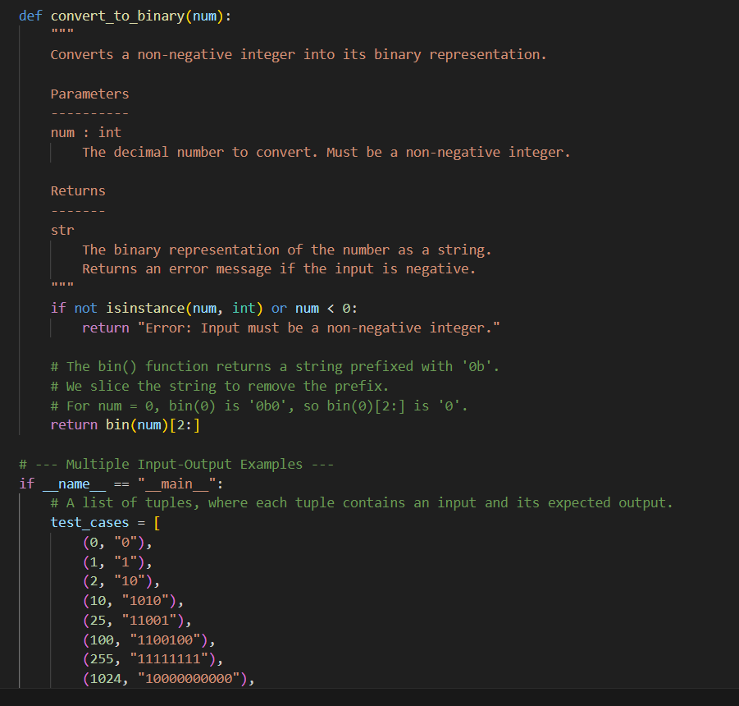
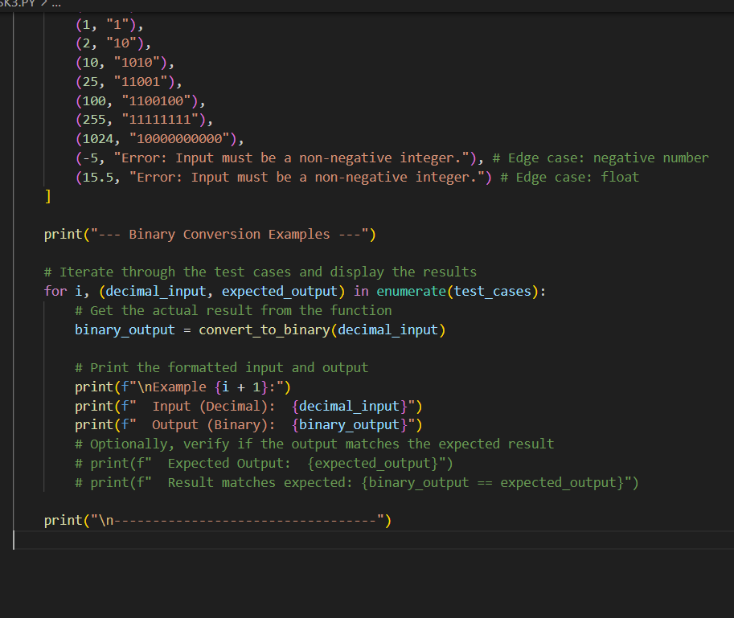
OUTPUT:-
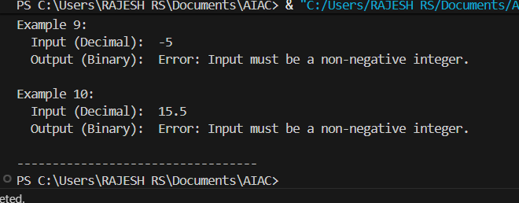
TASK4
TASK4 DESCRIPTION:-Create an user interface for an hotel to generate bill based on customer requirements

PROMPT:- Generate a python program to Create an user interface for an hotel to generate bill based on customer requirements

CODE:-
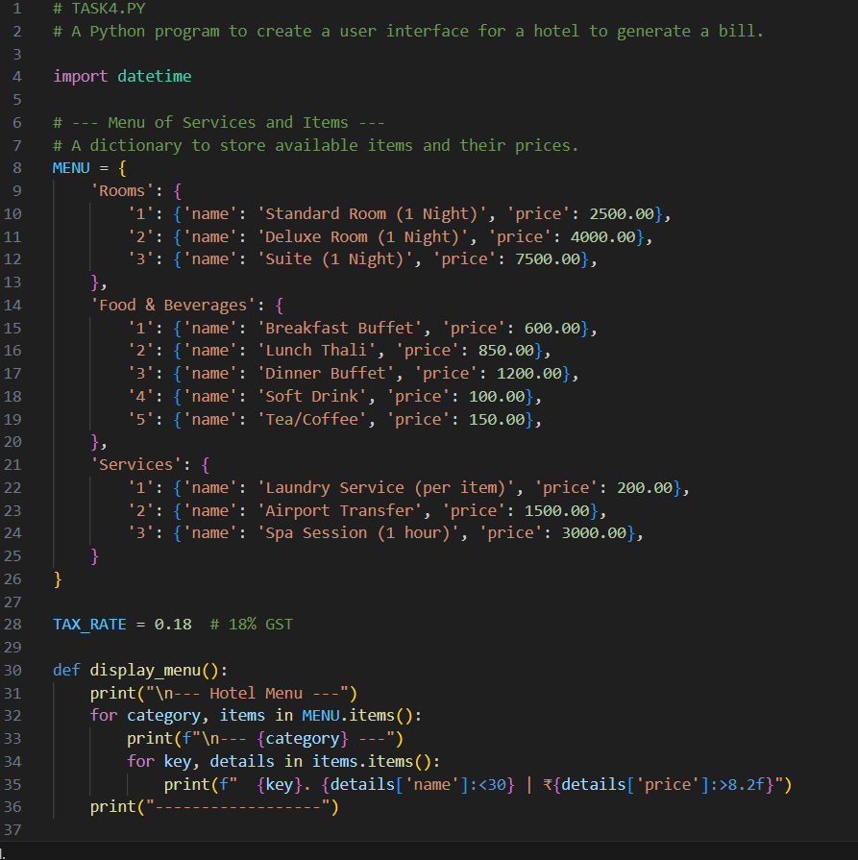
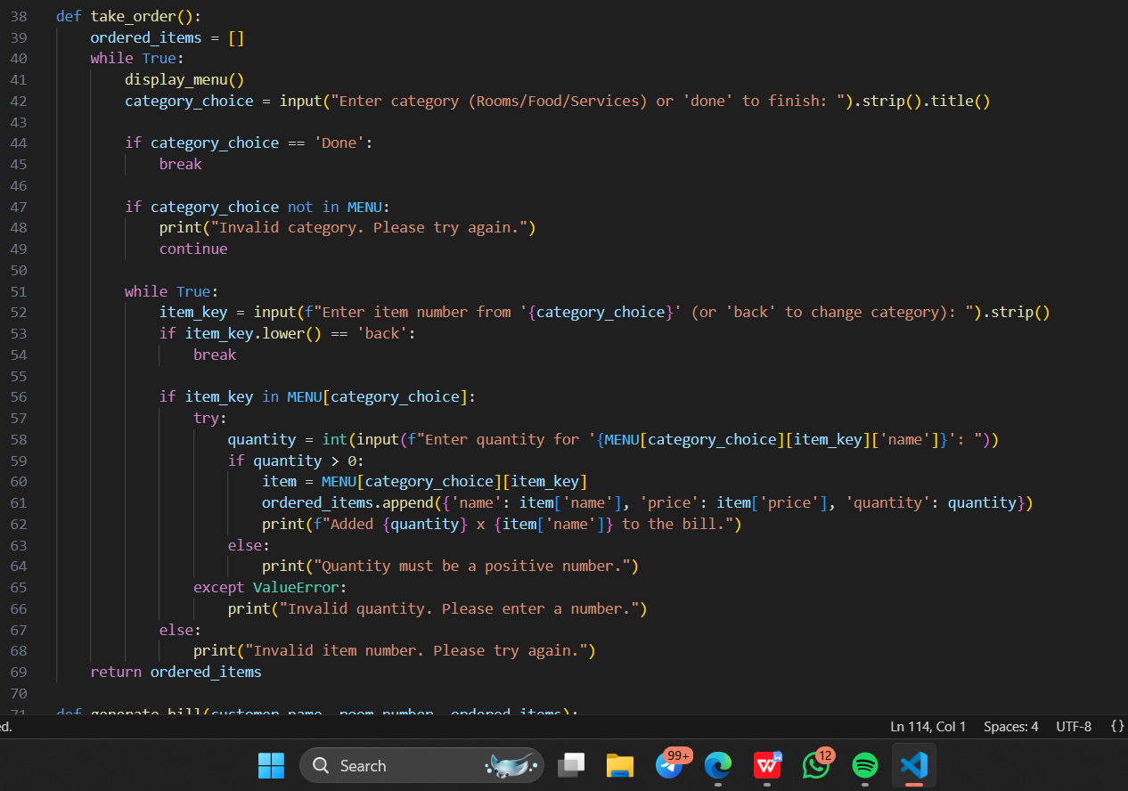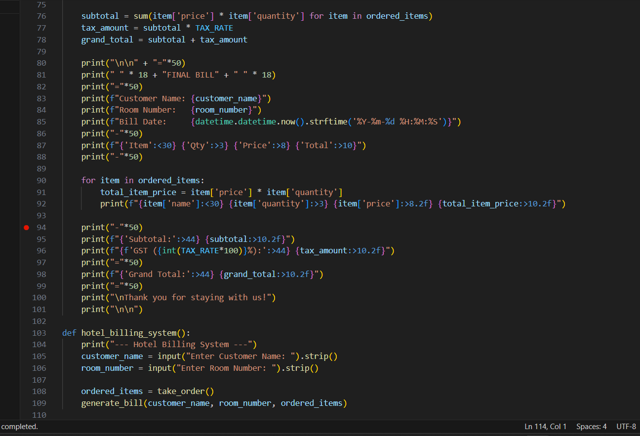
OUTPUT:
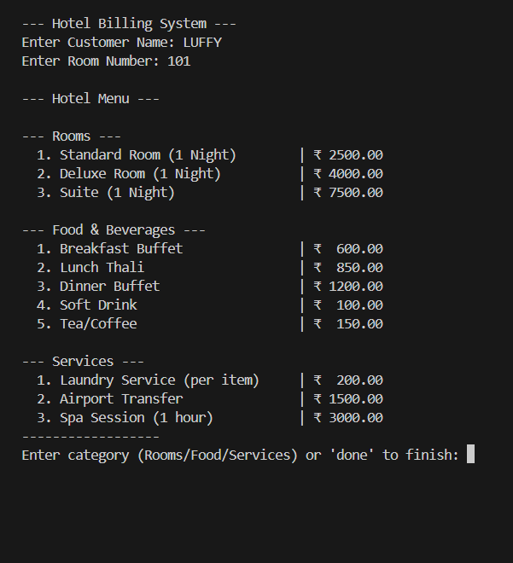
TASK5
TASK5 DESCRIPTION:- Analyzing Prompt Specificity: Improving Temperature Conversion Function with Clear Instructions

PROMPT:- Generate a python program to Improving Temperature Conversion Function with Clear Instructions
CODE:

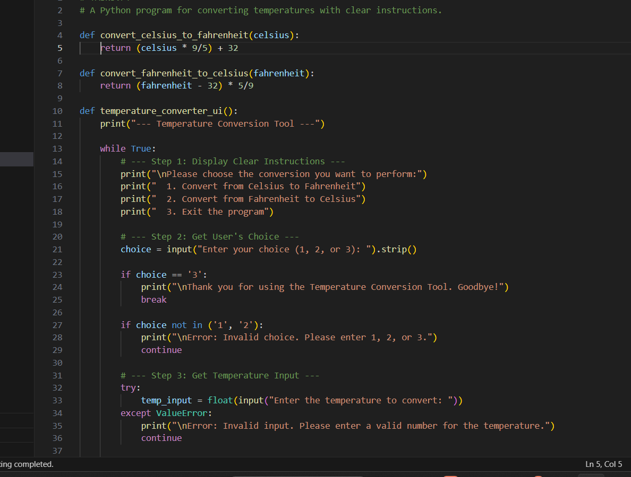
OUTPUT:-
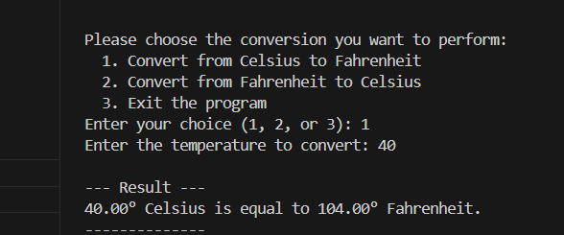

OBSERVATION:- From this assignment, I observed the practical role of prompt engineering and AI-assisted coding in generating Python programs. By giving different levels of instructions, the AI was able to produce complete implementations, examples, and even user interfaces.
- In Task 1, starting with only a function name and gradually adding docstrings and examples demonstrated how AI understands step-by-step instructions and builds code systematically.
- In Task 2, I observed how runtime inputs can be used for statistical calculations (average, median, mode), showing AI’s capability to handle mathematical logic on user-provided data.
- In Task 3, by providing multiple input–output examples for the convert_to_binary(num) function, I noticed how AI applied few-shot prompting to generalize and generate correct binary conversions for any decimal input.
- In Task 4, the hotel billing program highlighted how AI can extend beyond simple functions to build user-oriented applications, combining logic with interface design.
- In Task 5, refining the temperature conversion function showed how prompt specificity directly affects the accuracy, clarity, and usability of AI-generated code.

